Project Planning Phase
Project Planning Template (Product Backlog, Sprint Planning, Stories, Story points)

Date | 7 February 2026
Team ID | LTVIP2026TMIDS87719
Project Name | Heart Disease Analysis Using Tableau
Maximum Marks | 8 Marks

Product Backlog, Sprint Schedule, and Estimation (4 Marks)
Use the below template to create product backlog and sprint schedule
Sprint | Functional Requirement (Epic) | User Story Number | User Story / Task | Story Points | Priority | Team Members
Sprint-1 | Data Collection | USN-1 | As a user, I can import the heart disease dataset (CSV) into the MySQL database. | 2 | High | Member-1
Sprint-1 | Data Pre-processing | USN-2 | As a user, I want the system to clean and structure raw heart disease data using SQL queries. | 2 | High | Member-2
Sprint-1 | Data Storage | USN-3 | As a user, I want the processed heart disease data to be stored securely in MySQL for analysis. | 1 | Medium | Member-3
Sprint-2 | Data Analysis | USN-4 | As a user, I can analyze risk factors such as age, BMI, diabetes, smoking, cholesterol, and physical activity. | 3 | High | Member-1
Sprint-2 | Visualization | USN-5 | As a user, I can view interactive Tableau dashboards showing heart disease trends and comparisons. | 3 | High | Member-2
Sprint-2 | Dashboard Filters | USN-6 | As a user, I can filter dashboards by gender, age group, medical condition, and lifestyle factors. | 2 | Medium | Member-4
Sprint-3 | Story Creation | USN-7 | As a user, I can view a structured Tableau Story that explains heart disease insights step-by-step. | 2 | Medium | Member-3
Sprint-3 | Web Integration | USN-8 | As a user, I can access dashboards and stories through a Flask web application. | 2 | High | Member-2
Sprint-3 | Deployment | USN-9 | As a user, I can access the deployed web application online via Render. | 1 | High | Member-4
Sprint-3 | Performance Testing | USN-10 | As a user, I want dashboards to load efficiently even with larger datasets. | 2 | Medium | Member-3

Project Tracker, Velocity & Burndown Chart: (4 Marks)
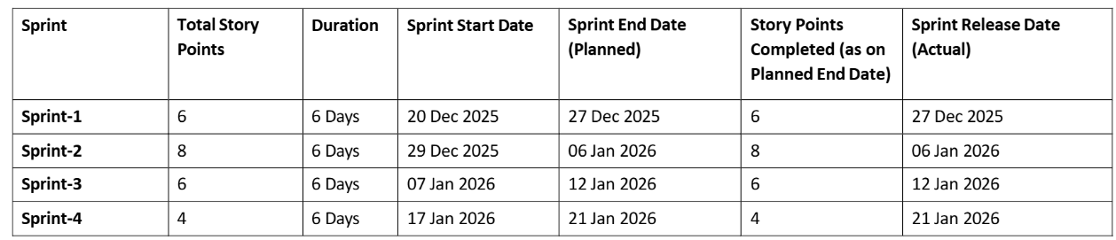

Velocity:
Total Story Points Completed = 24 Number of Sprints = 4 Average Velocity = 24 + 4 = 6 Story Points per Sprint If sprint duration = 6 days
Velocity per day = 6 + 6 = 1 Story Point per Day

